Getting **api/wallets** from postman through access token.

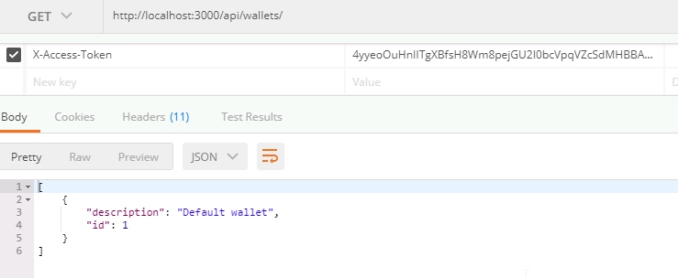

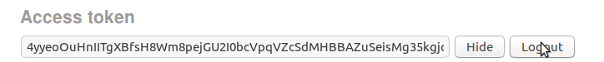

**After logging out from composer not able to access the resources**

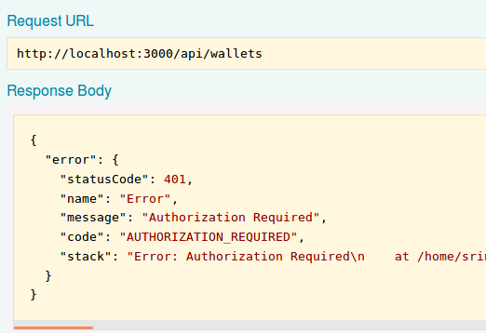

**With the same access token the resources are not accessible from the client end.**

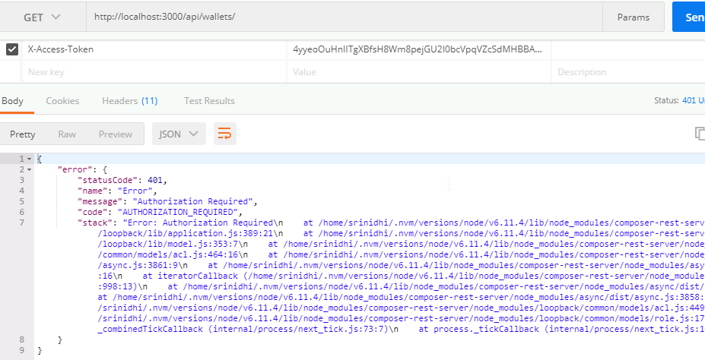

**Logging out from client side**

<http://localhost:3000/auth/logout>

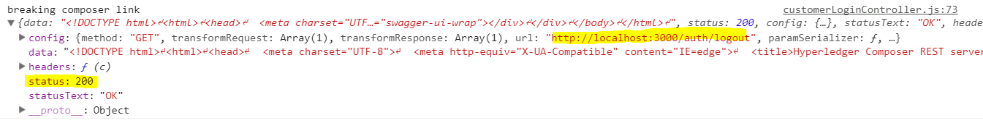

***Not able to get access here from the browser***

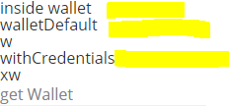

***Able to access from another client such as postman with the same access token***

